Data Warehouse Design and Development

Shila KC

National University

June 25, 2022

# ANA 655 Week4 Signature Paper

In a data mart environment, what kinds of outcomes do OLAP tools produce?

A data mart is a subset of data warehouse focused on a particular line of business, department or subject area. It generally provides easier access to the data to the specific team within the organization. It can be regarded as a simple form of data warehouse that is particularly focused on a single subject or line of business. For eg. if the marketing team is looking for data that would improve the campaign performance during the holiday season.

OLAP(Online Analytical processing) tools are used to make business decisions. They are subject oriented and consist of historical data and their size is very huge often in TBs or PBs. For example,using OLAP a user can request to analyze the customer data to display products sold in San Diego in the month of May and compare the revenue figure with the same products sold in June.

In the mid to late 90’s business found it very difficult to query data out of their relational databases transaction system. The queries are slower and not simple enough to navigate the data. The memory and processor were less than the average laptop today. Various vendors introduced proprietary solutions to address this problem and this led to the rise of OLAP. The main challenge here was to reduce on the fly processing while the user was navigating the data. They strived to minimize on the fly processing needed while the user was navigating the data. This was achieved by pre-processing and storing every possible combination of dimensions, measures and hierarchies before the user started their analysis. This allowed the data to appear instantaneously when the user investigated the information. While the market has matured greatly and some standards have emerged, the data optimization methods of OLAP are fundamentally the same.

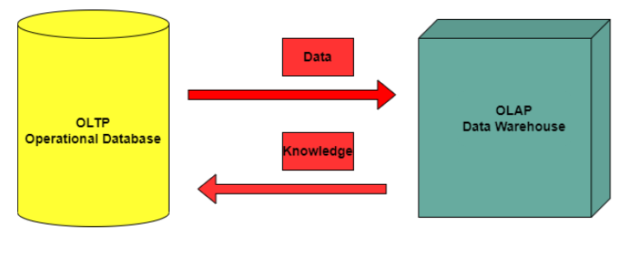  
*Figure 1: OLAP and OLTP*

OLAP is a powerful tool and is used in forecasting, statistical computations, and aggregations. They must be able to extract and summarize requested information according to the needs of an end user. OLAP is an approach that can answer analytical queries very swiftly. Typical applications include business reporting for sales, marketing, management reporting, business process management, budgeting, financial reporting and similar areas.

*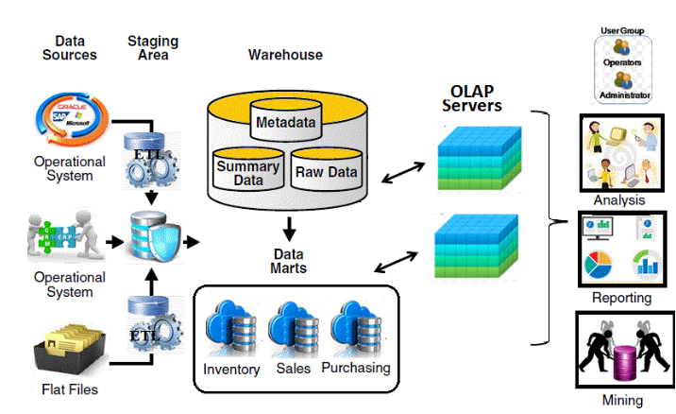  
Figure2: OLAP reports*

OLAP consists of three basic analytical operations:

1. Consolidation(roll-up)
2. Drill-down
3. Slicing and dicing

**Consolidation also** known as aggregation involves accumulation of data in one or more dimensions. For example, all sales offices are rolled-up to the sales department to anticipate sales trends.

**Drill-down:** It is breaking the data further into smaller parts. For example, if we consider the population of a country. In order to drill it down, we can expand it by state, cities etc. It is a technique that allows users to navigate through details of an individual product.

**Slicing and Dicing:**It is a feature where users can take out(slicing) a specific set of data of the OLAP cube and view (dicing) the slices from the different points.

OLAP enables the company to maximize their potential by transforming their corporate data into the most practical format for multi-dimensional analysis. OLAP products include IBM cognos, Oracle OLPA. OLAP features are also included in Microsoft Excel and Microsoft SQL Server’s Analysis services.

In our team project perspective, OLAP produces dashboard that reports e reports the data. For eg. The dashboard below shows the number of feedback it received from the user and the customer percentage based on state

. 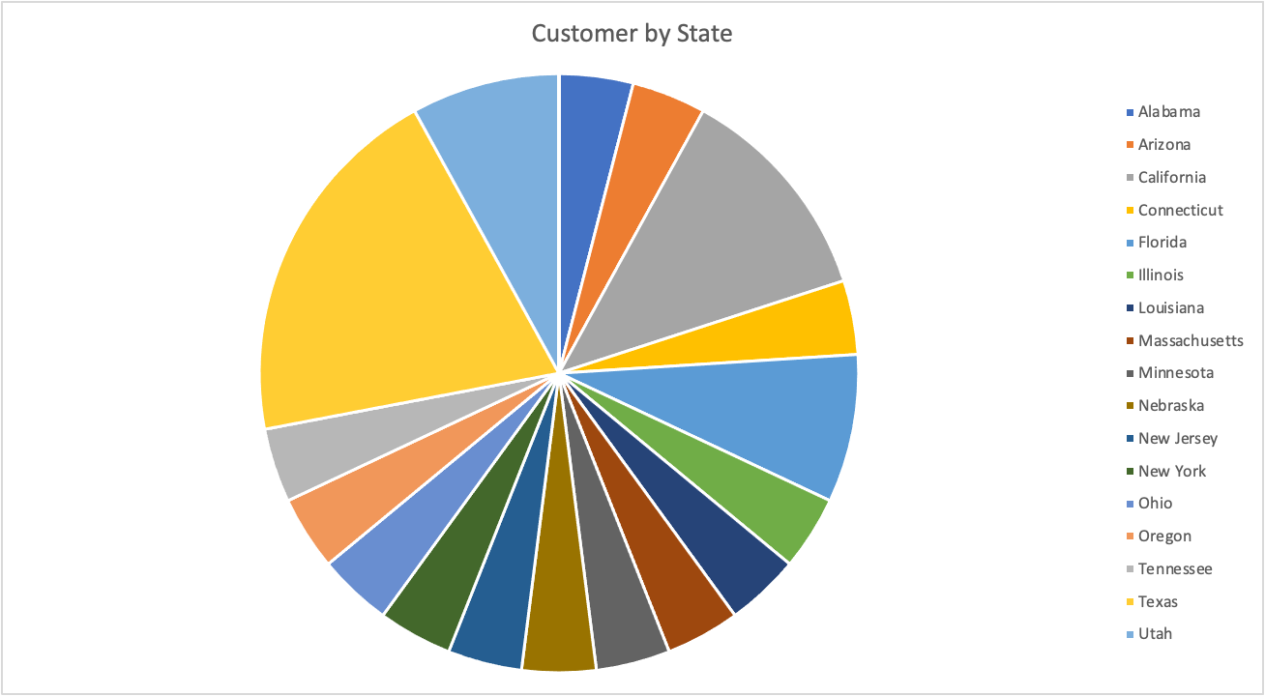

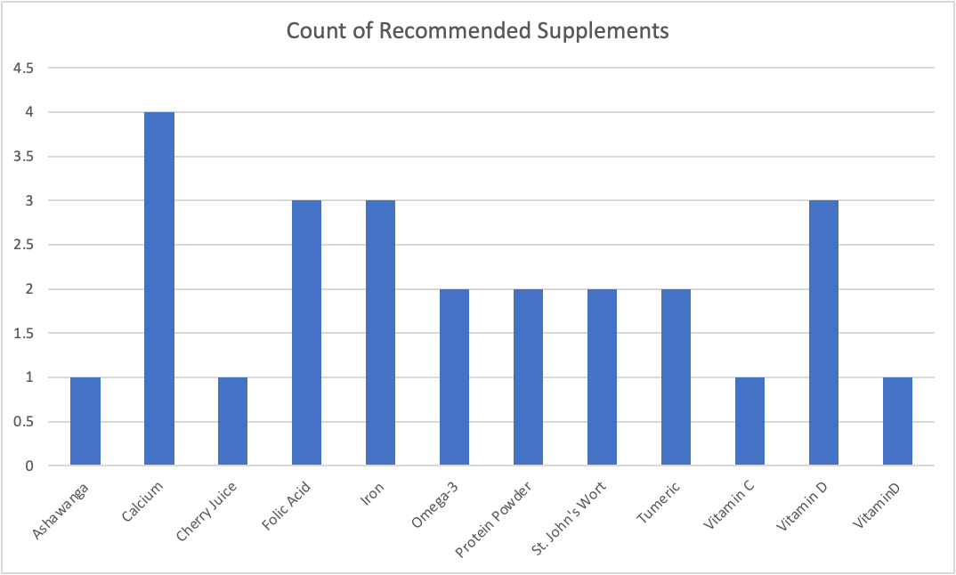

These reports were made by the use of Excel, which can be regarded as one of the OLAP tool..

References:

<http://www.sql-datatools.com/2015/09/sql-datawarehouse-olap-servers.html>

<https://www.educba.com/operations-in-olap/>

<https://www.ibm.com/cloud/learn/olap>